A Look at Liability and Funding in College Ultimate
By: Elijah Hoshide
The Berry College men’s ultimate frisbee team is one of the most successful Division 3 frisbee teams in the country. Berry has qualified for nationals every year since 2019, the second longest streak in the country for Division 3. However, a policy that has at times been a hinderance to the program is that Berry College requires the team to travel with a “chaperone” who can only be a faculty or staff member from the school. From what I’ve been told, it has been a way for the college’s legal team to handle liability concerns. This paper analyzes how Berry compares to other college ultimate frisbee teams in terms of chaperone requirements, liability requirements, and financial support.
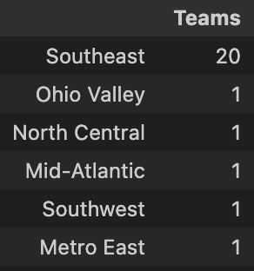
I sent out a survey to around 50-60 college ultimate frisbee teams, mostly from the Southeast region, but also 10 or so D-III schools that have historically been Nationals qualifiers. Of the 25 respondents, 80% of them were from the Southeast region while the 20% were each from different regions. Schools in Georgia and Tennessee were the most frequent respondents, accounting for 48% of the schools surveyed. Most the survey was men’s teams (72%) and they survey was close to being evenly split for Division 1 versus Division 3 teams (56% were D1, 44% were D3). 56% of the surveyed teams haven’t made nationals (D1 or D3) since 2010, while the other 44% have made nationals in either division at least once.
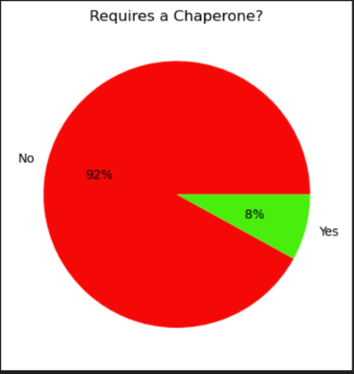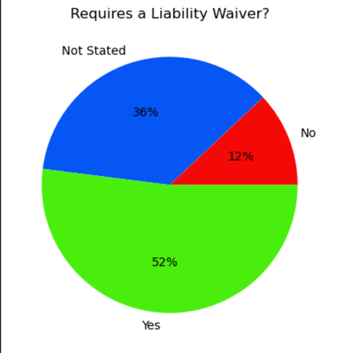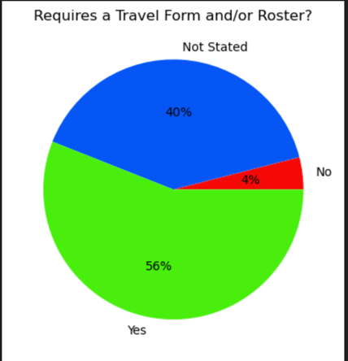
This analysis first focuses on how Berry compares to other schools in terms of chaperone and liability requirements. First, I examined what percentage of schools required a faculty or staff member to accompany teams to tournaments and looking to see if Berry is one of those schools. It turns out that only 8% of the schools surveyed required a faculty/staff member to be a chaperone at tournaments, and that 8% was comprised of Berry’s men’s and women’s team. Next, we looked at what percentage of schools required a liability form and a travel form/roster. 52% of schools requires a liability waiver and 56% of schools require some a travel form or roster of some sort. Both the Berry College men’s and women’s teams both require a liability waiver to be signed before tournaments and some form of a travel form signed and travel roster submitted.
Since it was clear that the survey showed that no other college frisbee teams require a chaperone besides Berry, I was curious as to why teams have the liability requirements that they do. I can’t say any factors like gender division, competition division, and nationals appearances caused teams to have liability and travel forms, but I can say that D1 teams had a significantly higher percentage of teams who required at least a liability and/or a travel form to be filled out prior to tournaments compared to D3 teams (93% vs 45%). This should be taken lightly because there could be other things that explain requiring liability and travel forms, but the division a team competes in could be a factor in needing liability and travel forms.
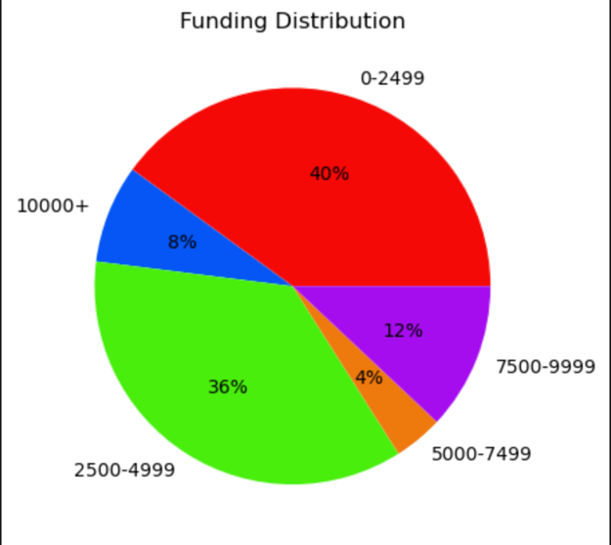
The next major part of my analysis focused on how Berry’s frisbee teams compared to other schools in terms of financial support from the school. When looking at the distribution of each team’s funding in our survey, 76% of teams received less than $5,000 of financial support from their school each semester. Berry’s teams fall into this majority, as both the men’s and women’s team receive between $2,500-$4,999 each semester (we are given around $5,000 to share each semester). For all the teams surveyed, the average percentage of funding received from the school that covered teams’ expenses was 52%. Berry’s women’s frisbee team falls above this average at about 60% while Berry’s men’s frisbee team falls below this average at about 40%.
Knowing this, I was curious if factors like Nationals appearances, gender division, or competition division can help explain why teams get the funding that they do. Once again, causality cannot be implied, but I can say that there was quite a bit more teams who have made nationals at least once since 2010 who receive at least $2,500 per semester in funding compared to teams who haven’t been to nationals at all since 2010 (82% vs 43%). Also, there were more D3 teams surveyed who received at least $2,500 per semester in funding compared to D1 teams (also 82% vs 43%). These findings should be taken lightly, but it is possible that nationals levels teams and being a smaller D3 school impact a team’s ability to get more funding than other schools.

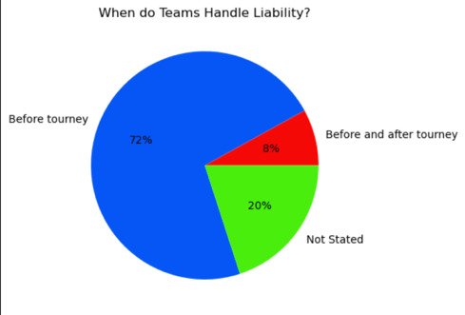


Additionally, I looked at when college ultimate teams handle liability and where funding is the highest. 72% of teams surveyed handle liability issues before a tournament begins and additional 8% not only handle liability before, but after the tournament is over as well. Both Berry teams primarily handle liability before a tournament. In terms of where funding is the highest in my survey, it appears that schools outside the Southeast region had higher funding, with most non-Southeast schools receiving at least $5000 per semester (60% of them), meanwhile, 85% of schools in the Southeast receive less than $5000 per semester. This should be taken with a grain of salt, as I would need to survey more schools outside of the Southeast region to say with more confidence that non-Southeastern schools receive more funding for their ultimate teams. In terms of states that receive the most funding in the Southeast, Tennessee teams clearly received the most funding, as 83.33% of Tennessee teams surveryed received at least $2500 per semester, with 2 teams even receiving at least $10,000 per semester.
To conduct the survey, I sent out an email over winter break to every single Southeast college ultimate team and a chunk of the best D-III teams in the country. This yielded 25 teams responding, but I didn’t have enough variables. I used usaultimate.org and ultizr to add variables to my data based off the schools that did respond. I used Jupyter notebooks in Python using Visual Studio Code to help analyze my survey, primarily by defining lots of different functions and dictionaries, but also by using the pandas and matplotlib libraries to help streamline the process.
In terms of weaknesses, this study was only sent out to men’s and women’s teams in the Southeast region and D-III teams whose emails I had access to, so there is some bias and an underrepresentation of the entirety of college ultimate teams in the United States. I also had to add some data given the team names and variables based on a free response question I gave in the original survey. One of the questions, the percentage of funding that covers expenses is a wild guess, it could be totally off or somewhat accurate. The respondents of this survey are college students in leadership positions, so accuracy in reporting is likely volatile. With this bias and convenience, however, the sample population of this survey shares geographic and school size similarities to Berry College. This means our sample is only of schools relatable geographically and in school size, as this was intentionally done to see how Berry’s frisbee teams compare to schools like them.
The Berry College ultimate frisbee teams have similar funding and liability requirements to other schools in the Southeast and in Division 3 ultimate frisbee. Most schools receive less than $5,000 per semester, have liability forms required to be signed before tournaments, and have travel forms required to be filled out before tournaments, and so do Berry’s frisbee teams. Berry’s ultimate frisbee teams are adequately supported for compared to other schools, so that is not worth being alarmed about. However, 92% of teams surveyed did not require a chaperone to travel with the team. Berry’s teams are the only teams who require a chaperone to travel with the team to tournaments in our sample. From the data, we can see that liability is handled in different ways by most schools. One could say having a chaperone travel with the team seems to be “extra” compared to other frisbee teams. I think it’s worth looking into not only why Berry requires a chaperone policy for the ultimate frisbee teams, but if it is necessary at all. Do the financial costs outweigh the benefits? My survey has reassured me of the Berry ultimate frisbee team’s financial support and I am grateful for it. Yet I am alarmed by the fact Berry’s ultimate frisbee teams require something that seemingly no other team requires.

